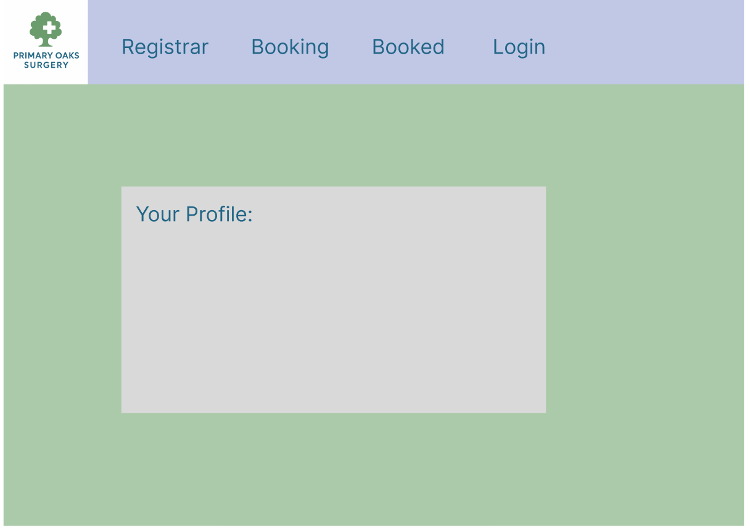
Here is the main menu for the Primary Oaks Surgery website with their company logo which perfectly represents the brand. The blue and green hue is used to subconsciously calm down the mind which can make it easily to find the relevant information at the patient(user) is searching for.

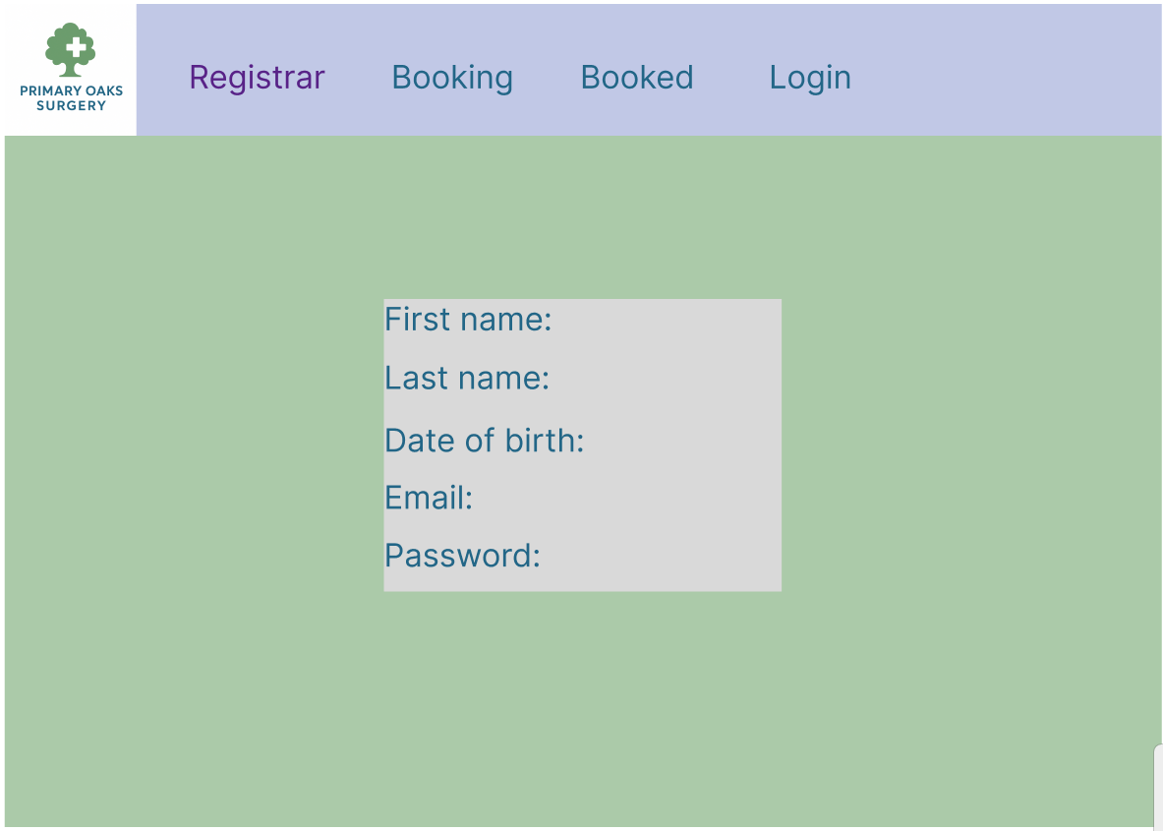
Now we are on to the registration where we ask for they first name, last name, birthday and password and email

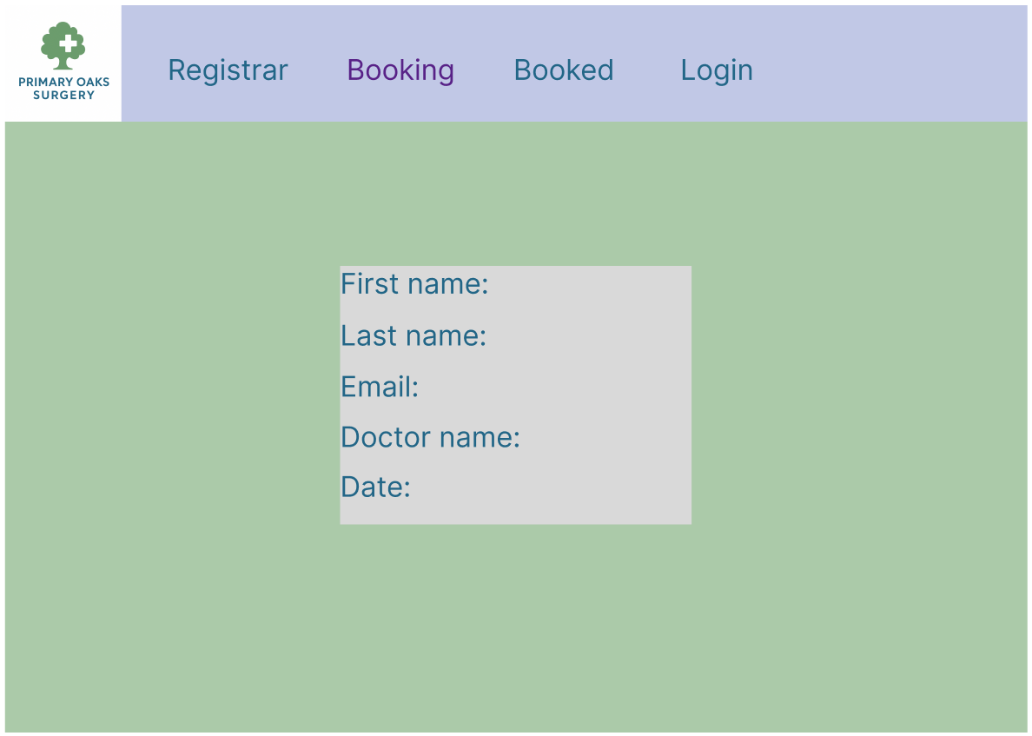
know we are on to the booking, their name and their email with the doctor they want and the date they want to go.
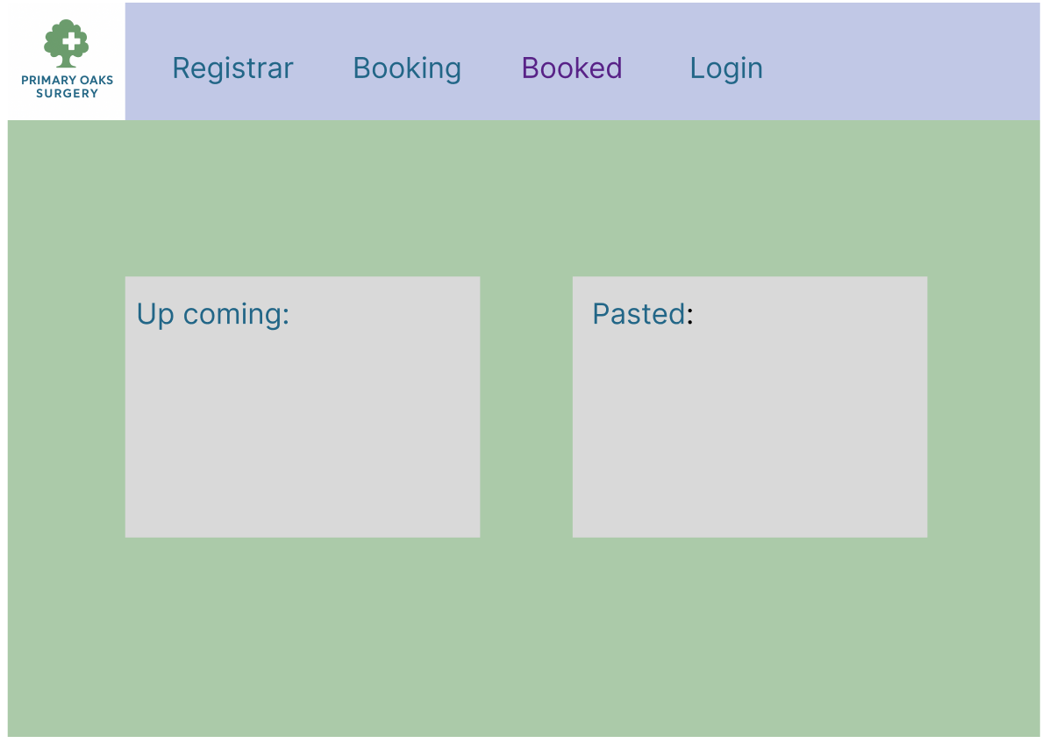
Know we can see any upcoming bookings and what has pasted
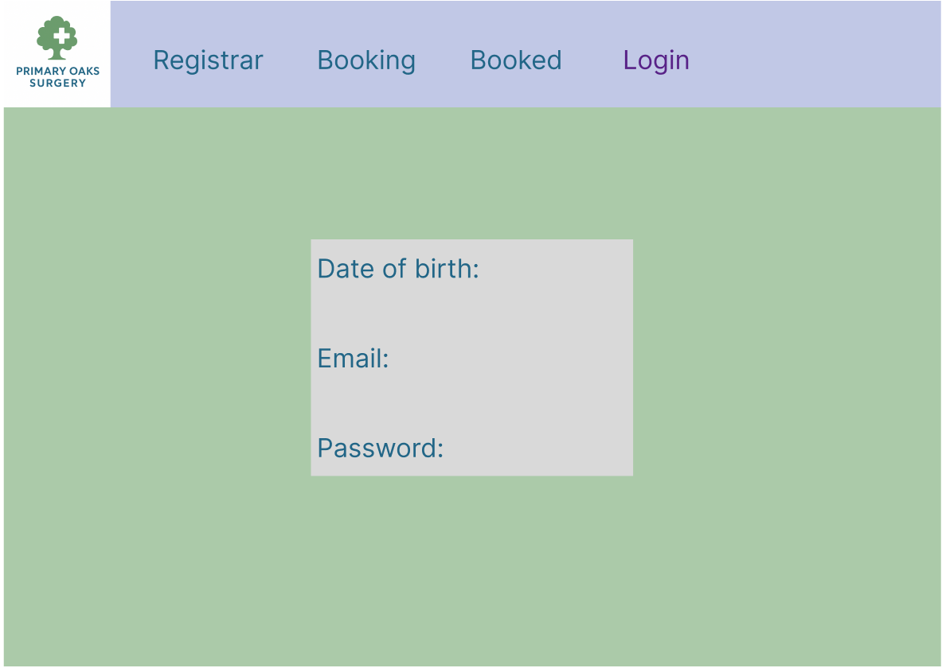
know we can login in.

